**User Manual**

**for**

**Gusty.bike**

**Prepared by**

**Jessica Spranger**

**Evan Shipman**

**Jacqueline Coates**

**Introduction**

This manual will go over how to install Wordpress and Mooshak on an AWS Ubuntu 18.04 interface, and how to setup your site the way you want it.

You can reference the tutorial that we based this guide on at:

<https://www.digitalocean.com/community/tutorials/how-to-install-wordpress-with-lamp-on-ubuntu-16-04#step-4-download-wordpress>

**Installation**

First, use the following steps to get the installer script and install Mooshak and Wordpress onto your machine.

1. SSH into your AWS Ubuntu 18.04 instance.
2. On your AWS instance, in your security groups, ensure that port 8180 is open for Mooshak to use.
3. Update:

**sudo apt-get update**

1. Download Git

**sudo apt-get -y install git**

1. Clone the repository: You will receive the installer.sh file.

git clone <https://github.com/eshipman/GustyDotBike>

1. Run the installer Script to download Mooshak and Wordpress. This will also create a log file for debugging purposes.

**cd GustyDotBike**

**sudo bash installer.sh | tee install.log**

1. The script will ask you
   1. A root password for the MySQL user.
   2. mysql will ask for a password user for wordpressuser. Enter a password of your choosing.
2. Some portions of the script may appear to freeze, this is normal. Please do not stop the script from running

**Setup Wordpress**

1. Once Wordpress is installed, go to the IP address (located on Instance, Description, IPv4 Public IP) on your web browser.
2. Follow the directions to set up your Wordpress website. Set up your username and password as see fit
3. The user should be able to see see the Dashboard on their monitor.
4. Go to Appearances, then Themes

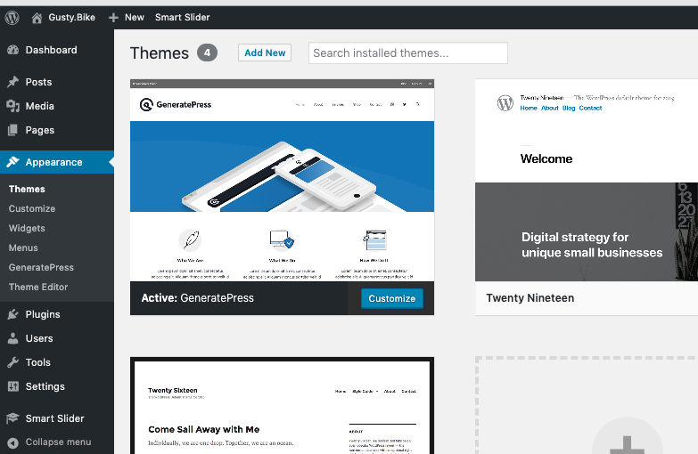

1. Click on the “Add New” button to pick a new theme
2. You liked the ‘GeneratePress’ theme, which you can search for there.

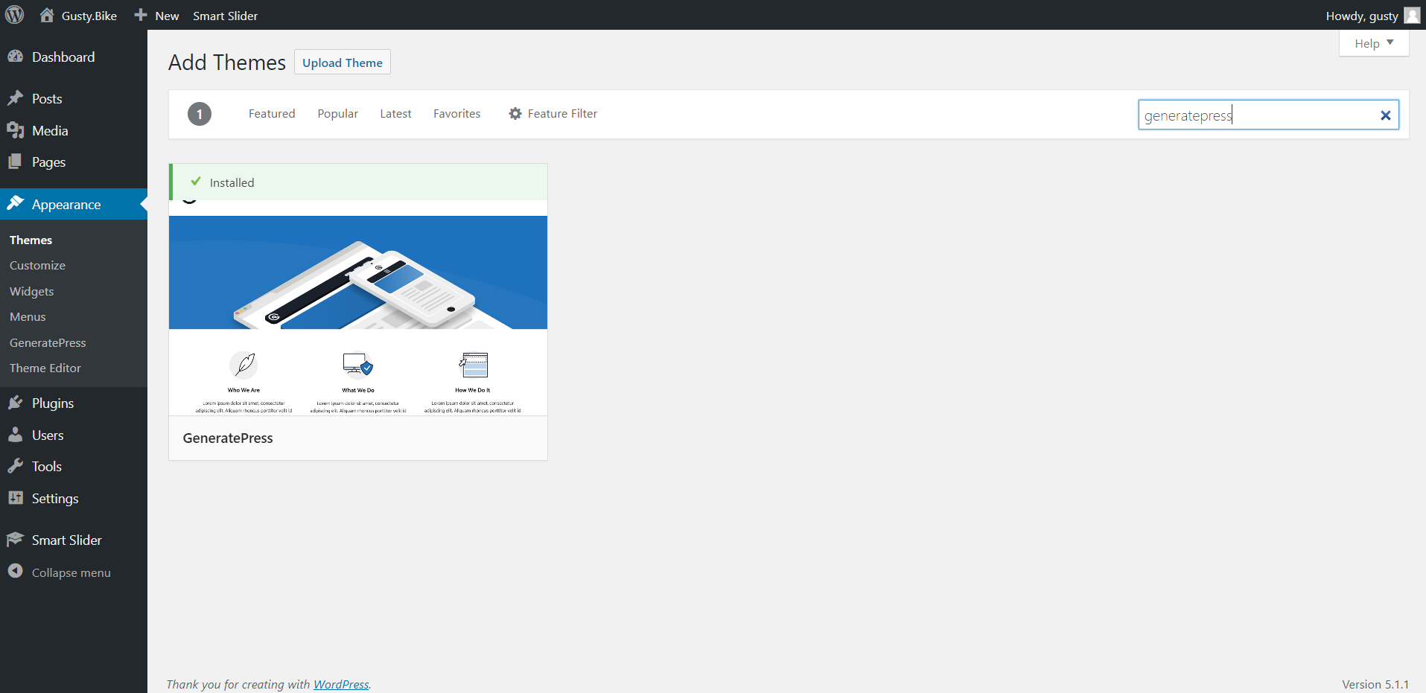

1. Once the theme has been installed to Appearance, then Customize.
2. You can change the coloring of your blog theme.
   1. To change the coloring to the orange you enjoy, login to your admin account and go to the site, click ‘Customize’. In the menu that appears you can click ‘Colors’.
   2. The orange you enjoyed was ‘#f2691a’ and if you’d like your site to be displayed as our prototype, you should make the background color and the link color this orange.

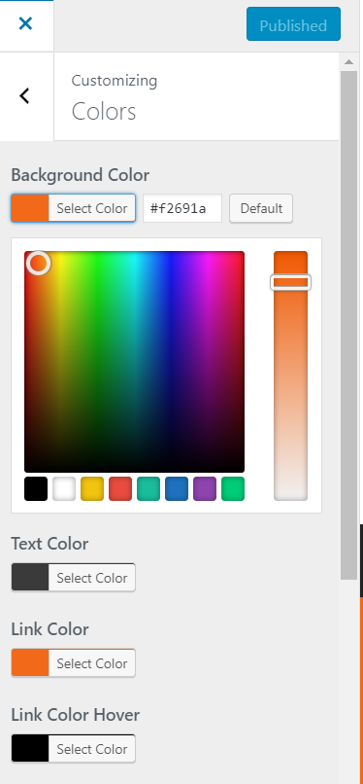

1. Add your logo to the Theme.
2. On the ‘Customize’ menu, click ‘Site Identity’ and upload your logo under ‘Logo’ and under ‘Retina Logo’. It is recommended you use a small picture size for this.
3. In the Site Identity tab you can also edit your blog title and tagline.

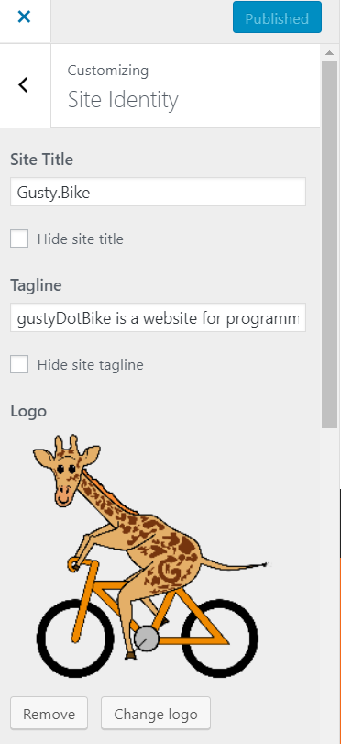

1. Now we will create a page for Mooshak
   1. Click on Menu
   2. Create a new menu and input a name
   3. Check the Header Menu box and go to next
   4. Click on the “Add Item” button
   5. Type in “Mooshak” in the Add New Page bar
   6. Click the add button
   7. Then exit out and go to the pages section and click on the newly created page.
   8. Pages has a visibility option: public, private, and password protected. If you want the mooshak link to be protected, you can set up a password to enter the page. Then you can give it to your students.

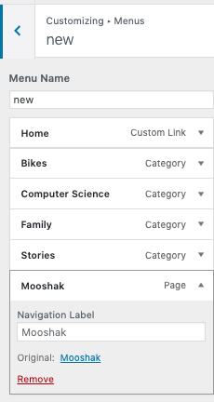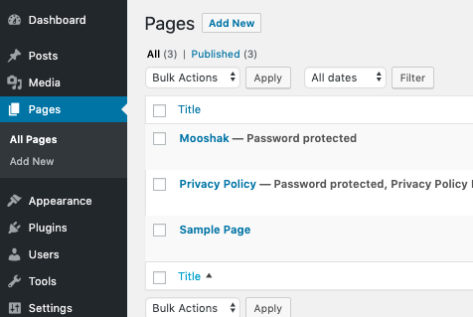

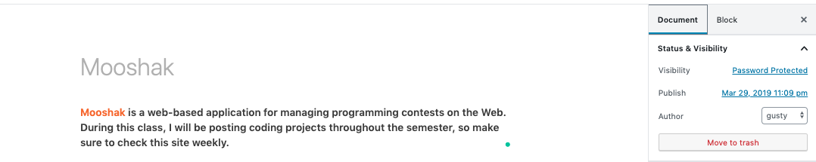

1. Add any more additional Pages or Custom Links as you see fit
2. Save your work by clicking the “Activate & Publish” button at the top left-hand corner.
3. Editing the page
   1. Click the X button at the left corner of the screen
   2. Go to Pages, then Add New
   3. Give the page a title
   4. Click the +
   5. Then click Paragraph
      1. There are other blocks you can choose from, like image and pdf embedder

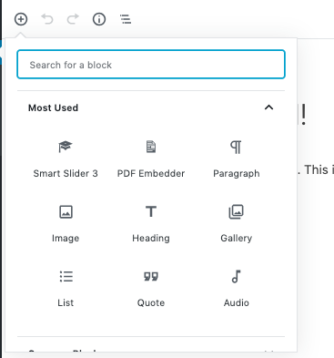

* 1. Copy and Paste This set of text into to box
     1. Mooshak is a web-based application for managing programming contests on the Web. During this class, I will be posting coding projects throughout the semester, so make sure to check this site weekly.
  2. Highlight one of the words in the sentence
     1. Click on the link button, put in the Mooshak link into the bar

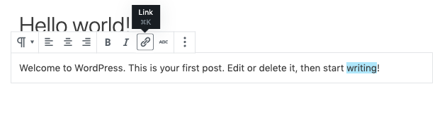

* + 1. Then, on the right-hand side go to Documents
    2. Click on Visibility and select Password Protected
       1. For the password put in **mooshakMoo**
       2. This prevents non-students from access the Mooshak link.
    3. Click the blue button to Publish/Update the page

1. Posts and Categories
   1. On your menu there are 4 categories: Bikes, Computer Science, Family, and Stories. These will help organize your posts. When editing a post make sure to check which category you would like your post to be. If you do not like these categories you can remove them as you see fit.
2. Creating Users
   1. Wordpress comes with a user option, that allows others to have access to your website. There is a subscriber options that allows students to get updates on your blog.

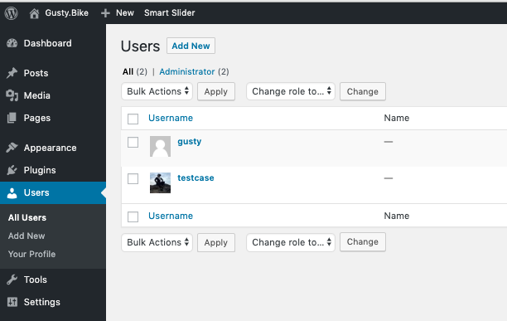

* 1. For more information go to the link below:

<https://themeisle.com/blog/user-registration-in-wordpress/>

**Key Pointers**

**Website Files**

If you would like to view the css files for your website, simply go to Appearances, then Theme Editor. Each theme has their own individual files, so you can make custom edits for each of the themes. These files can also be edited be edited in the CSS editor under Customize.

**Deleting Unnecessary Space**

If you are not using certain themes, it is best to delete them since they take up extra space. To delete a theme, click on theme details, and at the bottom right corner click on the delete button.

**Plugins**

Based on the requirements for our client here are the plugins.

Disable Comments - prevents comments from being posted on part of a site or the entire site

Smart Slider 3 - a slider for images and videos

Akismet Anti-Spam - is a spam blocker

PDF Embedder - allows users to import PDFs into post and pages

*Plugins are basically apps for your website. They add functionality to your site.

**Updating Wordpress**

The permissions given by this install were too secure to allow Wordpress to automatically update, so you cannot update them through the GUI with the current permissions. When a wordpress update become available, do the following:

1. Temporarily change the permissions:

**sudo chown -R www-data /var/www/html**

1. Update wordpress with the GUI, since you now have permissions.
2. Change the permissions back to what they were previously, entering your sudo username where indicated:

**sudo chown -R www-data /var/www/html**

[**Mooshak**](http://algorithmics.comp.nus.edu.sg/~mooshak/cgi-bin/execute/73590774356197?help+./procedures/before/teams)

In order to visit the Mooshak page you need to go to **IP:8180/mooshak**. Here you can login to access Mooshak 2’s features.

To get to the Mooshak admin page go to IP:8180/mooshak/Admin.html

or

Use the normal login page and log into as the administrator with the default username **admin** and default password **admin**.

If you are unable to login go to this directory /home/mooshak/data/configs/users/admin/ in your AWS instance. From there, you may revert to an earlier password, based on one of the .data.tcl.* files with the desired timestamp. To do this, copy that file overtop of the current configuration “.data.tcl”.

**Create a contest**

There are different types of programming contest, [ICPC](https://mooshak2.dcc.fc.up.pt/mooshak/admin/creating-an-icpc-contest) and [Prolog](https://mooshak2.dcc.fc.up.pt/mooshak/creating-prolog-contest). To create a new contest, open the Contests folder and then give a name to a new folder. Once created define the following attributes: a designation for your contest, who is organizing it, email of contact for the organization, day and hour for starting and terminating the contest.

**Key Tutorials**

If you get confused on the Mooshak installation, here is the how-to tutorial(9.33)

<https://mooshak2.dcc.fc.up.pt/mooshak/installation-ubuntu>